**Lab.01 AWS Management Console and Global Infrastructure**

Required screen capture are embedded in this paper

This lab works on Free-Tier accounts only.

Before the start lab sesions let’s make sure your laptop’s browser is up to date.

The AWS Management Console supports the following browsers:

* Google Chrome Latest three versions -Version 75.0.3770.142 (64-bit)
* Mozilla Firefox Latest three versions –Version 68.0 (64-bit)
* Microsoft Edge Latest three versions
* Microsoft Internet Explorer 11
* Apple Safari for MacOS Latest two versions

**AWS Global Infrastructure**

* Region, Availability Zones and End Points:
* **AWS Region:** Nothing but worldwide geographic location of AWS datacenters. Each datacenter is completely independent.
* **AWS Availability Zones :** They are isolated datacenters can be located in same location or close locations to make sure there latency won’t be problem.

AutoScaling.ap-south-1.amazonaws.com

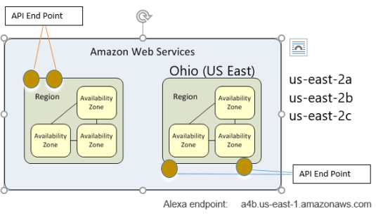

* **End Points:** API entrance point **,**To reduce data latency in your applications, *most Amazon Web Services* offer a Regional endpoint to make your requests. An endpoint is a URL that is the entry point for a web service. For example,

https://dynamodb.us-west-2.amazonaws.com is an entry point for the Amazon DynamoDB service.

* **AWS Direct Connect**: Dedicated Connections are 1G or 10G physical Ethernet ports dedicated to a single customer. Each Dedicated Connection supports 50 private or public Virtual Interfaces and 1 transit Virtual Interface.
* **Telecomm vendors**

**AWS Console Overview**

Left Top : AWS logo is your Console home access next is all AWS Services you can pick from or just type the service name inside of the search area ( no need to know full name of service)

Right Top : the most important part is your account and region information. There are also alert notifications ( with a bell icon) and a cloud shell ( this is new; you can open and start using Amazon CLI commands here no need to connect to your account with SSH for test purposes). Also, you can access all AWS documentation and support center from this bar

Middle Pane: it is your work area for service configurations or monitoring

Left pane: is your navigation pane. When you select any AWS service, all service sub menus will show in there

Right Pane: information about the current middle pane and Generative AI for help desk.

You can fully customize your console home with a light or dark theme also, all objects in the middle pane can be grabbed and moved, and you can add or remove your widgets.

**Lab Details:**

Step 01: Log in to AWS

Step 02: Find your region and switch your region to US.East (N.Virginia) if it is different.

Step 03: From the Navigation bar, find Support Center and select it.

Step 04: From Select Support Center find your

1. Account Number : **381491903900**
2. What is your support Plan : **Basic**
3. Do you see your support case history? how many cases are pending: **0 cases pending**
4. How many AWS Support plans are available: **4 support plans.**
   1. Basic
   2. Developer
   3. Business
   4. Enterprise
5. Does the Developer support plan provide AWS Managed Services: **No**
6. What is the name of AWS generative AI assistant: **Amazon Q**

Step 05: From Navigation Bar how to pin AWS services on our navigation

Pin the services exact order of EC2 ,VPC,IAM,S3, RDS

Step06: And capture your pinned screen here like mine below.

Test our pins do they work or not: They work fine.

Step 06: From the new navigation bar select ***Amazon Translate***

**Amazon Translate** is a text translation service that uses advanced machine learning technologies to provide high-quality translation on demand. You can use Amazon Translate to translate unstructured text documents or to build applications that work in multiple languages.

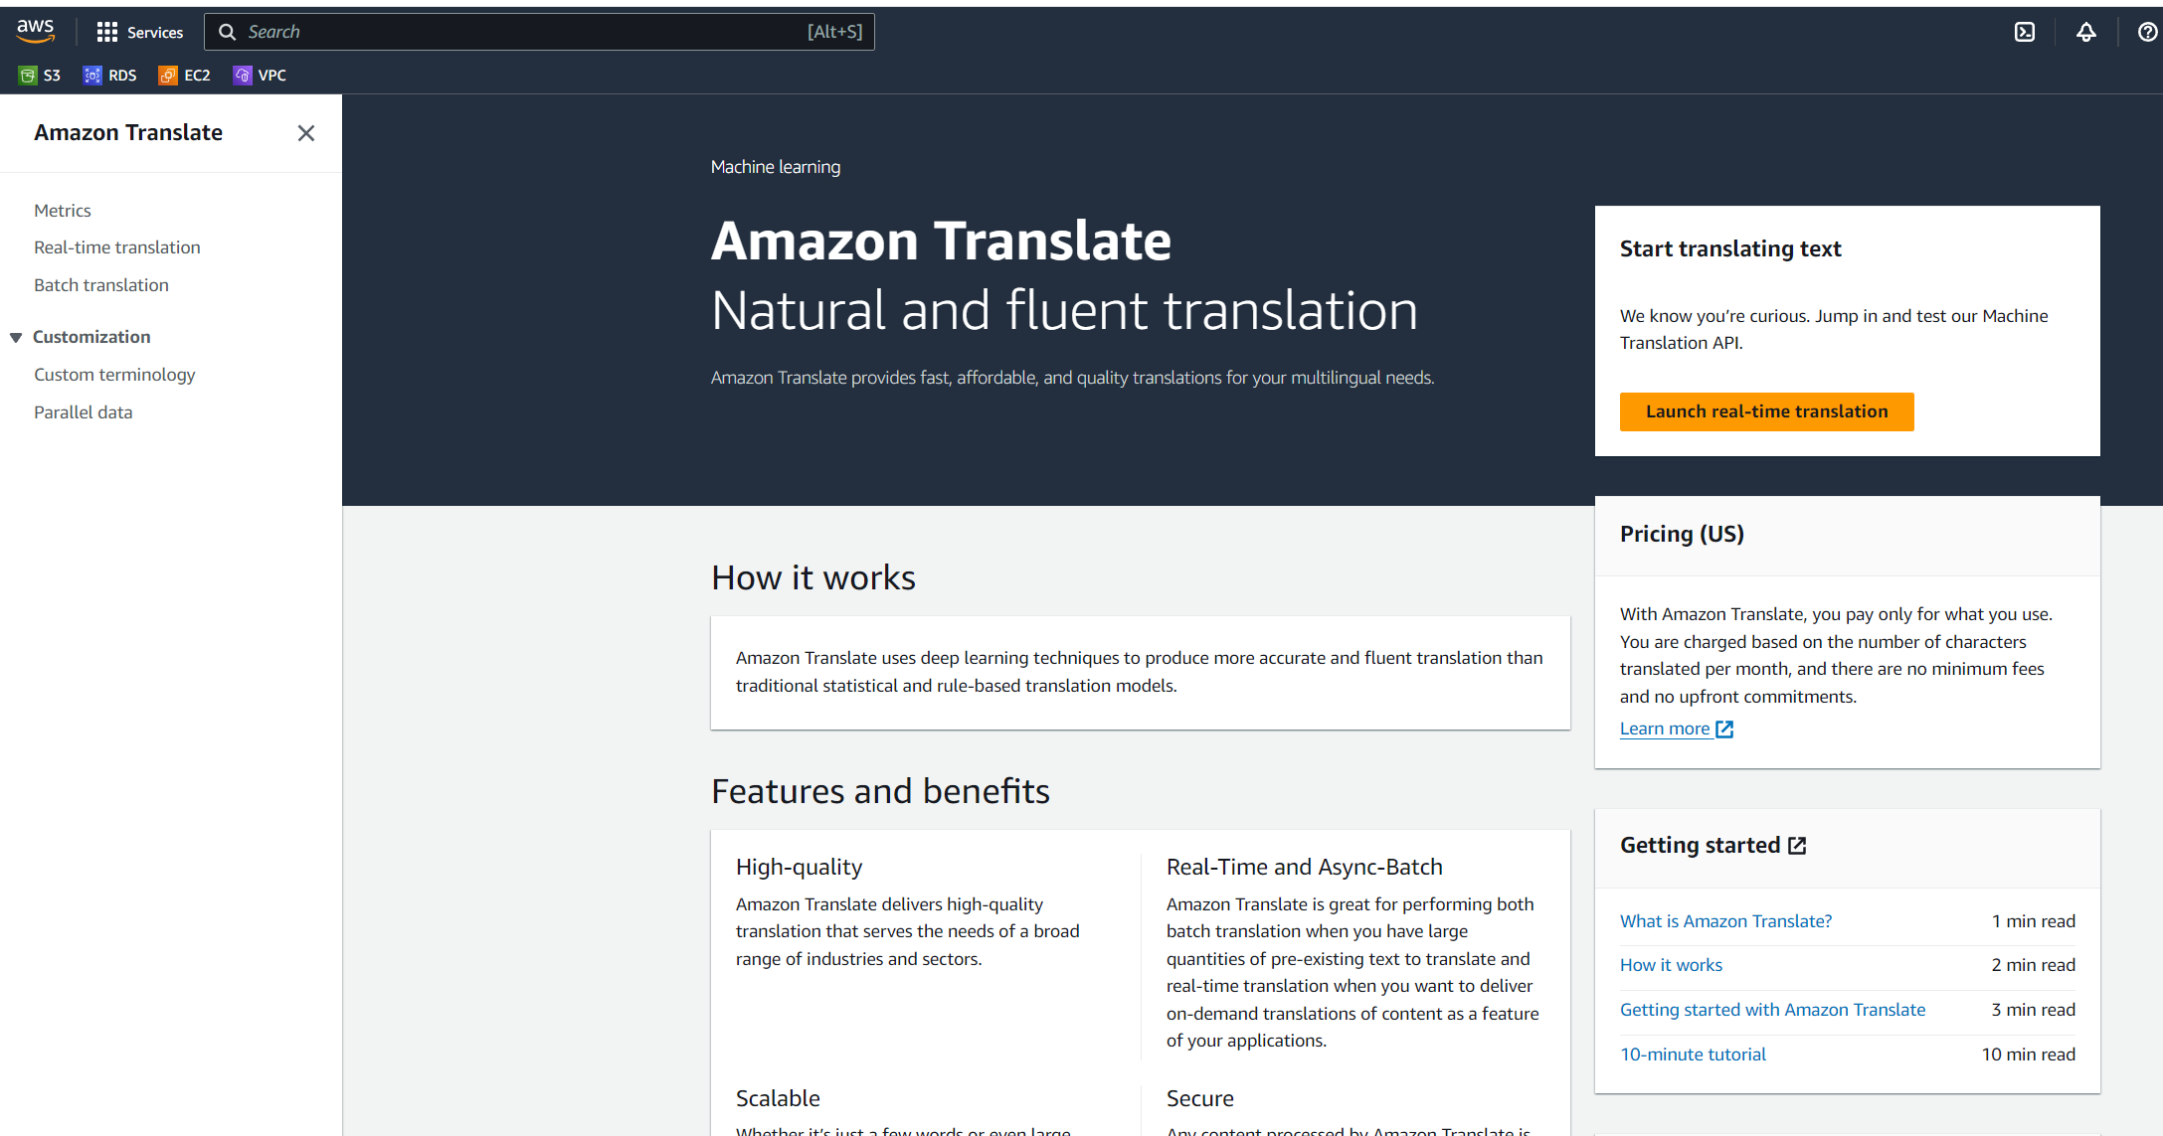

**Sub Functions:**

**Metrics**: Amazon Translate provides preconfigured graphs that show you the most important metrics for your solution. Each graph offers a window into your solution's performance. You can change the time range that the graphs show to get different views of how your solution is performing over time

**Real Time Translation:** Main function , text to text real-time translation.

**Batch Translation:** if you have multiple files and they all need to be translated for this, you need to create a job and point to the location of the files.

**Custom Terminology:** Using custom terminology with your translation requests enables you to make sure that your brand names, character names, model names, and other unique content is translated exactly the way you need it, regardless of its context and the Amazon Translate algorithm’s decision.

Step 08 : From new navigation bar select ***Amazon Polly***

**Amazon Polly** is a service that turns text into lifelike speech, allowing you to create applications that talk, and build entirely new categories of speech-enabled products. Amazon Polly is a Text-to-Speech service that uses advanced deep learning technologies to synthesize speech that sounds like a human voice. Your task must be saved to an S3 bucket.

**Sub Functions:**

**Text-to-Speech**: Main function. Select one of the engine Generative, Long form ,neural or standart

**Lexicons:** Pronunciation lexicons enable you to customize the pronunciation of words. Amazon Polly provides API operations that you can use to store lexicons in an AWS region.

**Plain text vs. SSML:** You can use Amazon Polly to generate speech from either plain text or from documents marked up with Speech Synthesis Markup Language (SSML). With SSML tags, you can customize and control aspects of speech such as pronunciation, volume, and speech rate.

***( just retired) Speech synthesis****is simply a form of output where a computer or other machine reads words to you out loud in a real or* ***simulated voice****played through a loudspeaker; the technology is often called text-to-speech (TTS). ... All that may change in future as computer-generated speech becomes less robotic and more humanS3 synthesis tasks*

**S3 synthesis tasks:** S3 storage location of final output voices and their process status (scheduled, failed, completed, in Progress)

Required Submission for this Lab

1. Submit whole Step4 .

1. Account Number : **381491903900**
2. What is your support Plan : **Basic**
3. Do you see your support case history? how many cases are pending: **0 cases pending**
4. How many AWS Support plans are available: **4 support plans.**
   1. Basic
   2. Developer
   3. Business
   4. Enterprise
5. Does the Developer support plan provide AWS Managed Services: **No**
6. What is the name of AWS generative AI assistant: **Amazon Q**

2. In Step 6 Amazon Translate : Chose whole your syntaxes ( half a page) from your favorite book or news and translate to any language that you wonder about and add a screen capture here

3. In step 7 Amazon Polly: Write down your own words, including your name and last name, and convert them to MP3 and attach the final MP3 file with your paper.

Thanks

Good luck.